–

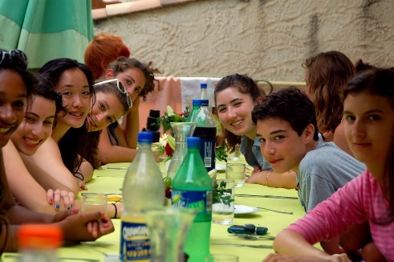
Celebrating a Harvest Supper
By: Janice Miller
As the 2017 gardening season is drawing to a close, we celebrated the fruit of our labor with our neighbors in the [NEIGHBORHOOD NAME] neighborhood on October 21st, 2017 at the [COMMUNITY CENTER NAME] community center. This garden is particularly special to us, as we have been able to involve the youth group from the First Baptist Church in its creation.
Particularly Youth Pastor Jason Jefferson has been instrumental in the effort to have the youth group assume ownership of this garden, thereby making sure that it will be carried on for years to come.
We enjoyed a potluck of harvest dishes cooked with vegetables from the garden. A huge success was the pumpkin pie contest, with Micayla Peters taking first price.
The highlight of the night was our veggie bingo, for which several local businesses continue to donate prizes. Thank you for all you do!
Amicably, Janice

Garden #5 Completed!
By: Sam Doe
2017 marks the year we have put in FIVE gardens total throughout the Greater Seattle area. Lorem ipsum dolor sit amet, consectetur adipiscing elit. Aliquam vitae sagittis urna, eget tincidunt sem. Integer et odio scelerisque, sollicitudin purus finibus, efficitur erat. In pellentesque faucibus risus nec sodales. Nam lorem quam, condimentum mollis enim quis, volutpat finibus massa. Maecenas a vulputate ipsum. Vivamus hendrerit ante tempus, eleifend sapien non, vestibulum urna. Maecenas metus lorem, ultricies a leo sit amet, maximus fermentum metus. Nam eu orci vel tortor eleifend luctus non eget mi. Praesent porttitor egestas gravida. Curabitur posuere lorem non vestibulum maximus.
Morbi scelerisque fermentum eleifend. Duis tempus ex lacus, mattis suscipit sapien sodales id. Ut mi diam, rutrum a eros eu, consequat suscipit lectus. Aliquam neque urna, porta nec ligula eget, dictum rutrum urna. Pellentesque elit nulla, malesuada ac tellus lobortis, scelerisque vulputate nibh. Sed hendrerit mi nec ornare porta. Cras justo sem, tristique finibus tempus vel, convallis condimentum turpis.
Happy 2018 to you all & thank you for your continued support!
~ Sam ~
MARK YOUR CALENDARS!
NOVEMBER
4 – 3 PM Canning Workshop
12 – 6 AM Bird Watching
18 – 3 PM T-day Cooking Class
DECEMBER
2 – 5 PM Birdseed Ornaments
17 – 3 PM Seasonal Potluck
JANUARY
1 – 7 PM ANOTHER EVENT
1 – 7 PM ANOTHER EVENT

