–
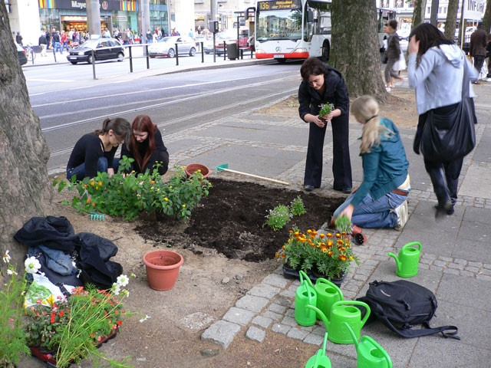 |  | Wheelbarrows & Shovels  - Seattle Garden Collective Newsletter  - 10/31/2017
Building Community, One Garden at a Time |  | In This Issue
- Celebrating a Harvest Supper (P.1)
- Garden #5 Completed (P.3)
- Canning Workshop (P.4)
- Join Us: Bird Seed Ornament
Making & Get Together (P.4)

Celebrating a Harvest Supper
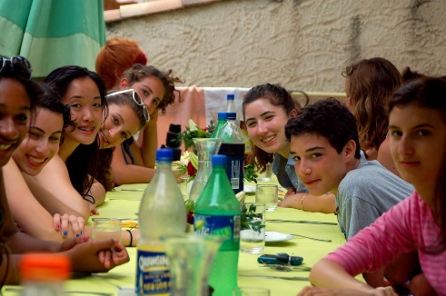
By: Janice Miller
THANK YOU TO OUR SPONSORS!
HomeMart
Landscape Depot
THANK YOU TO OUR MEMBERS & VOLUNTEERS!
Without you, the Seattle Garden Collective would not be able to do the work we do. YOU are making this all possible!
Member of the Month:
Darden Desmond

As the 2017 gardening season is drawing to a close, we celebrated the fruit of our labor with our neighbors in the [NEIGHBORHOOD NAME] neighborhood on October 21st, 2017 at the [COMMUNITY CENTER NAME] community center. This garden is particularly special to us, as we have been able to involve the youth group from the First Baptist Church in its creation.
Particularly Youth Pastor Jason Jefferson has been instrumental in the effort to have the youth group assume ownership of this garden, thereby making sure that it will be carried on for years to come.
We enjoyed a potluck of harvest dishes cooked with vegetables from the garden. A huge success was the pumpkin pie contest, with Micayla Peters taking first price.
The highlight of the night was our veggie bingo, for which several local businesses continue to donate prizes. Thank you for all you do!
Amicably, Janice

NOVEMBER
4 – 3 PM Canning Workshop
12 – 6 AM Bird Watching
18 – 3 PM T-day Cooking Class
DECEMBER
2 – 5 PM Birdseed Ornaments
17 – 3 PM Seasonal Potluck
JANUARY
1 – 7 PM ANOTHER EVENT
1 – 7 PM ANOTHER EVENT
Details:
seattlegardencollective.com/
events
upcoming EVENTS

From the President

By: Angela Dickerson
As 2017 draws to a close, we look back on yet another successful year. Lorem ipsum dolor sit amet, consectetur adipiscing elit. Aliquam vitae sagittis urna, eget tincidunt sem. Integer et odio scelerisque, sollicitudin purus finibus, efficitur erat. In pellentesque faucibus risus nec sodales. Nam lorem quam, condimentum mollis enim quis, volutpat finibus massa. Maecenas a vulputate ipsum. Vivamus hendrerit ante tempus, eleifend sapien non, vestibulum urna. Maecenas metus lorem, ultricies a leo sit amet, maximus fermentum metus. Nam eu orci vel tortor eleifend luctus non eget mi. Praesent porttitor egestas gravida. Curabitur posuere lorem non vestibulum maximus.
Morbi scelerisque fermentum eleifend. Duis tempus ex lacus, mattis suscipit sapien sodales id. Ut mi diam, rutrum a eros eu, consequat suscipit lectus. Aliquam neque urna, porta nec ligula eget, dictum rutrum urna. Pellentesque elit nulla, malesuada ac tellus lobortis,.
Happy 2018 to you all & thank you for your continued support!
Angela

"Even with WIC I was not able to provide my kids with the nutrition they needed because it was so hard to get to the grocery store without a car. This garden has been so great for us, and I've been learning so much about growing food and how to preserve it." - Debra S., local resident, about the inaugural garden established in February of 2017.

Please consider donating to the Seattle Garden Collective! We need lots of the following:

- seed starting supplies
  - peat pots
  - seed mix
  - seeds etc.
- garden tools
  - wheelbarrows
  - shovels
  - hoes
  - rakes
Call/email us at 206-555-1212 or sgc@gmail.com.
URGENTLY NEEDED

Garden #5 Completed!
By: Sam Doe

2017 marks the year we have put in FIVE gardens total throughout the Greater Seattle area. Lorem ipsum dolor sit amet, consectetur adipiscing elit. Aliquam vitae sagittis urna, eget tincidunt sem. Integer et odio scelerisque, sollicitudin purus finibus, efficitur erat. In pellentesque faucibus risus nec sodales. Nam lorem quam, condimentum mollis enim quis, volutpat finibus massa. Maecenas a vulputate ipsum. Vivamus hendrerit ante tempus, eleifend sapien non, vestibulum urna. Maecenas metus lorem, ultricies a leo sit amet, maximus fermentum metus. Nam eu orci vel tortor eleifend luctus non eget mi. Praesent porttitor egestas gravida. Curabitur posuere lorem non vestibulum maximus.
Morbi scelerisque fermentum eleifend. Duis tempus ex lacus, mattis suscipit sapien sodales id. Ut mi diam, rutrum a eros eu, consequat suscipit lectus. Aliquam neque urna, porta nec ligula eget, dictum rutrum urna. Pellentesque elit nulla, malesuada ac tellus lobortis, scelerisque vulputate nibh. Sed hendrerit mi nec ornare porta. Cras justo sem, tristique finibus tempus vel, convallis condimentum turpis.
2017 in Numbers:
abandoned lots reclaimed
since 2016:
one garden feeds:

number of residents whose life
was changed for the better:
5

10 families of 4

200

Donec pulvinar augue sed augue dictum molestie tincidunt eu metus. Fusce at justo dolor. Nulla aliquet at nisl nec vestibulum. Vestibulum gravida ullamcorper dui a mattis. In eget efficitur purus, vel posuere justo. Ut vitae justo scelerisque nisi scelerisque sodales. In a ipsum sodales arcu fermentum rhoncus vitae vitae ipsum. Praesent consequat velit justo, vel convallis metus fermentum quis.
Cras id mollis nisl. Sed nulla lorem, varius ac iaculis vitae, gravida eu leo. Lorem ipsum dolor sit amet, consectetur adipiscing elit. Praesent risus eros, interdum eu mi egestas, viverra gravida turpis. Fusce at lectus iaculis, lacinia sem et, bibendum dui. Donec eleifend aliquet tellus, vitae blandit massa tincidunt at.
Happy 2018 to you all & thank you for your continued support!
~ Sam ~

Preserve it!
We are proud to announce our first canning workshop on November 4, 2017 (Saturday) at 3 PM. We will gather at [COMMUNITY CENTER NAME] community center to learn about conserving tomatoes, beans and other produce we have harvested “the old-fashioned way”.
Cost of this 2-hour program is $20 (donation), which includes the jars and other materials needed. Don’t worry if you are interested but cannot pay the full amount, there are scholarships available.
WHERE: COMMUNITY CENTER NAME
WHEN: November 4, 2017 at 3 PM
CONTACT: Lizzy DiAngelo, 206-569-4848
lizziD@gmail.com

Bird Seed Ornament Making & Get-Together
Our feathered friends need to eat, too, this winter! Join us for this fun kids’ workshop to make bird seed ornaments, chat and enjoy some seasonal treats.
WHERE: COMMUNITY CENTER NAME
WHEN: November 4, 2017 at 3 PM
CONTACT: Lizzy DiAngelo, 206-569-4848
lizziD@gmail.com
What to bring: Bird seed, ITEM 1, ITEM 2, ITEM 3

Company Name
Street Address
City, ST ZIP Code

Recipient Name
Address
City, ST ZIP Code

