Harvest Social
Let’s get together for our Harvest Social & Potluck!

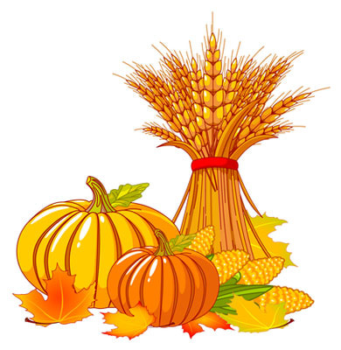
When: November 4, 2017, 3 PM - until the cows come home
Where: XXX Community Center at ADDRESS
We have some FUN activities planned, including
- SPECIAL GUEST Coco the Clown
- and a BARN DANCE featuring “On the River”
This FREE event is for all ages (voluntary $5 donation requested to cover costs). Bring your own table service, a lawn chair and a beverage of your choice.

The Seattle Garden Collective reclaims abandoned city lots in order to convert them into community gardens, thereby restoring community in low-income neighborhoods while contributing to a healthier diet and curbing food insecurity in the immediate area.
CONTACT: Janice Miller, 206-555-1212 | seattlegardencollective.com/contact | seattlegardencollective@gmail.com

