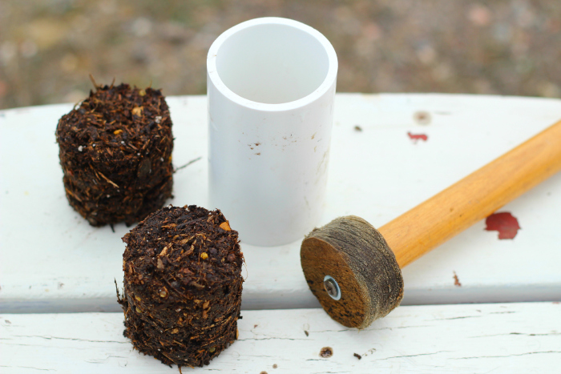
Thank you to our sponsors, HomeMart and Landscape Depot for helping us make this a free event!
JOIN US!
What: Soil block making
When: Every second Saturday of the month at 3 PM
Where: XXX Community Center at ADDRESS
Open to all age groups.

The Seattle Garden Collective reclaims abandoned city lots in order to convert them into community gardens, thereby restoring community in low-income neighborhoods while contributing to a healthier diet and curbing food insecurity in the immediate area.
CONTACT: Janice Miller, 206-555-1212 | seattlegardencollective.com/contact | seattlegardencollective@gmail.com

