What we do:  The Seattle Garden Collective reclaims abandoned city lots in order to convert them into community gardens, thereby restoring community in low-income neighborhoods while contributing to a healthier diet and curbing food insecurity in the immediate area.  Since our founding in late 2016, we have successfully reclaimed 5 abandoned lots.  These gardens now feed an average of 10 families of 4 each = 200 local residents whose quality of life was changed for the better. |  |  | The Seattle Garden Collective  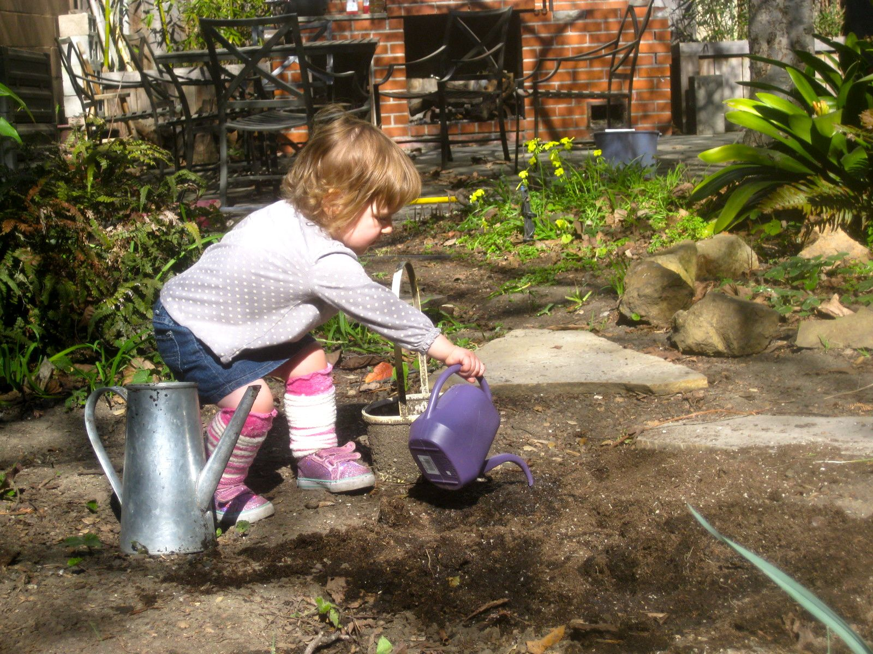  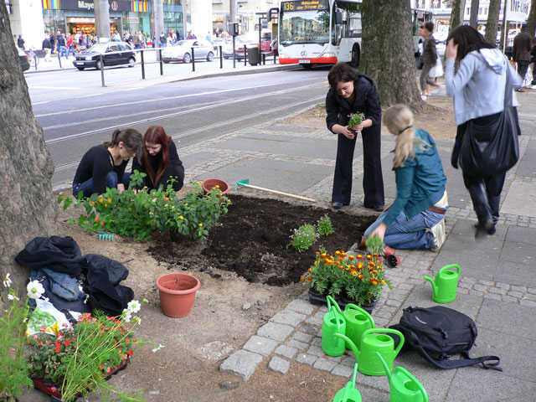  Changing people’s lives, one community garden at a time.  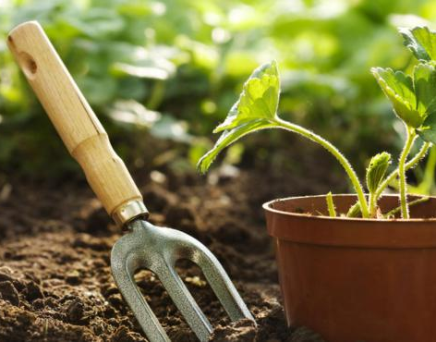  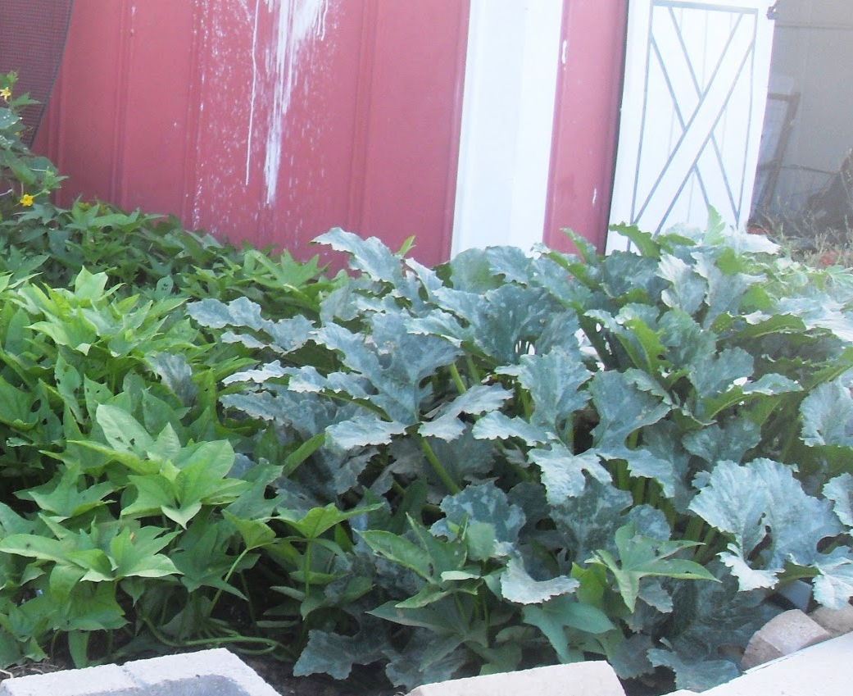  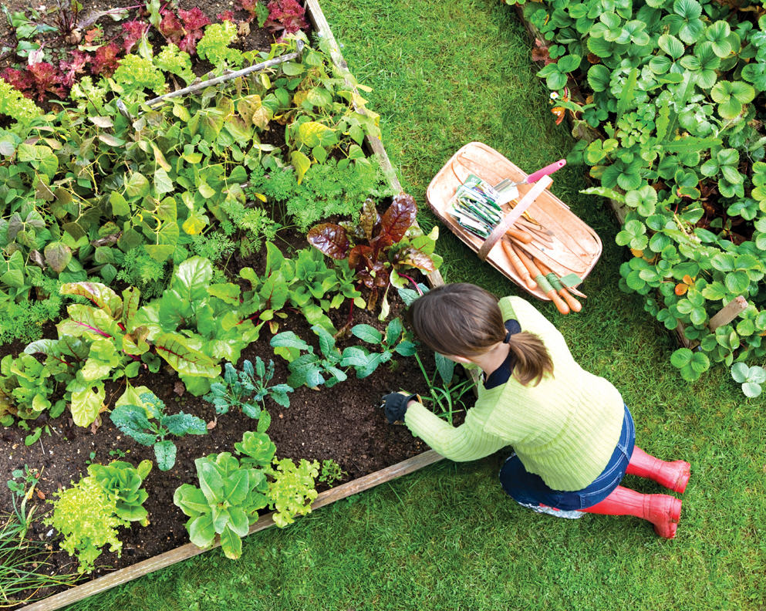

Our Story  In December of 2016, friends Jim Smith, Sam Doe, Janice Miller, Joe Miller and Mara Myers came together in a coffee shop near Pioneer Square to discuss an issue that had been on all of their minds for some time: food deserts throughout the Greater Seattle area. Since then, the Seattle Garden Collective has grown from this founding group of five to now 25 members. We may have started on a cold, gray winter day, but ever since we've been working hard to dot Greater Seattle with all the colors that should be found on your plate, one abandoned city lot at a time.  Join us today by visiting  OURDOMAIN.com/membership  "Even with WIC I was not able to provide my kids with the nutrition they needed because it was so hard to get to the grocery store without a car. This garden has been so great for us, and I've been learning so much about growing food and how to preserve it." - Debra S., local resident, about the inaugural garden established in February of 2017. |  |  | A Healthy Diet is a Human Right!  We work to bring healthy food to underserved, low-income neighborhoods. This empowers neighborhood residents to take charge of their diet and builds community at the same time.  Consider Contributing  Please consider donating your time and resources to this very important endeavor. Whether you can spare a little or a lot, it will make a difference in people's lives! Please refer to our website at  OURDOMAIN.com/donations  for a current list of urgently needed items.  A BIG Thank You to  We would like to thank our sponsors, HomeMart and Landscape Depot, for their continuing support. Without their in-kind and financial help the Seattle Garden Collective would not be able to change people's lives like we have.  We are also infinitely grateful to our members and volunteers who keep putting in countless hours to dig up beds, build sheds, hold classes and more.  www.OURDOMAIN.com  206-555-1212

